Physics 100 (Stapleton) Name: _________________________________
Car Calculations Practice

Formulas: $v=\frac{d}{t}$ $W=Fd$ $KE=\frac{1}{2}mv^{2}$

$KE=output energy$ $W=Input Energy$ $\%Efficiency= \frac{Output Energy}{Input Energy}×100\%$

- Use the data in the table and graph below to complete the table on the right.

Car Mass (kg) | 0.12
Video Frame Rate (frames/sec) | 240
Floor Tile Width (m) | 0.305
Fewest Video Frames to Cross a Floor Tile (#) | 28
Average Wheel Force
Total Work Distance
Approximate Total Work Required to Wind Car
Car Maximum Velocity -- From Video (m/s)
Car Maximum Kinetic Energy
Car Efficiency

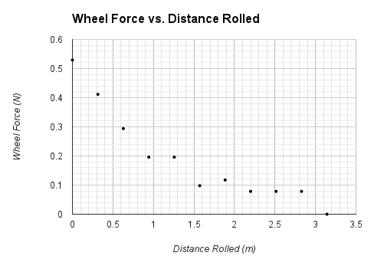

- Use the data in the table and graph below to complete the table on the right.

Car Mass (kg) | 0.185
Video Frame Rate (frames/sec) | 240
Floor Tile Width (m) | 0.305
Fewest Video Frames to Cross a Floor Tile (#) | 26
Average Wheel Force
Total Work Distance
Approximate Total Work Required to Wind Car
Car Maximum Velocity -- From Video (m/s)
Car Maximum Kinetic Energy
Car Efficiency

